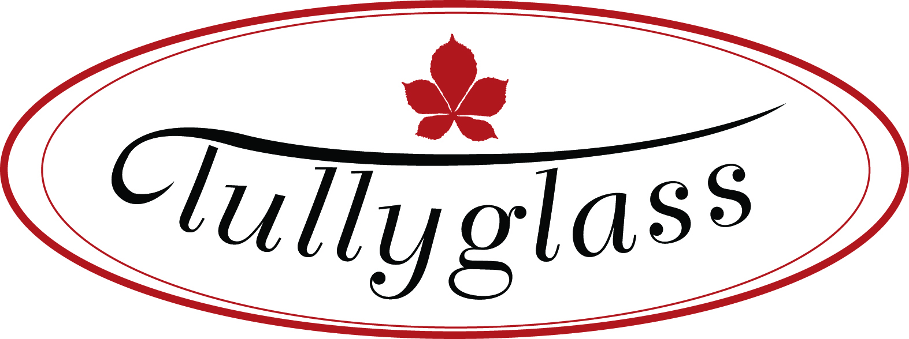

PHONE NUMBERS OF ALTERNATIVE HOTELS AND BED & BREAKFASTS
CLOSE TO TULLYGLASS HOUSE HOTEL

HOTELS

ADAIR ARMS HOTEL (1.3 miles) 028 25653674
GALGORM MANOR (2.2 miles) 028 25881001
ROSS PARK HOTEL (7 miles) 028 25891663

BED & BREAKFASTS

MARLAGH LODGE (4.1 miles) 028 25631505
(Main Larne Rd, ½ mile from r ’about)

PINE GROVE LODGE (2.8 miles) 028 25643434
(Heather, Beside Countryman Inn, between Ballymoney & Cushendall Rd)

MEADOW VIEW (4.8 miles) 028 25880738

(Outside Cullybackey)

SLEMISH HOUSE (1.3miles) 028 25647383
(Betty, Behind Adair Arms)

TAXI NUMBERS

ECABS 028 2565 2200
ARROW 028 2563 7711
BLACK & WHITE 07917 472 774
BALLYMENA CABS 028 2563 0707
BRAID 028 2586 1400
BROADWAY TAXIS 028 256 49494
BROS TAXIS 028 2564 7272 / 028 2564 4477
BS TAXIS 028 2564 0004
DIAMOND TAXIS 028 2565 8888
JOES TAXIS 028 2564 7799
REGENTS TAXIS 028 2564 4777
RING A CAB 028 2564 1010
SHARP TAXIS 028 2564 0000
TC TAXIS 028 2564 4440

